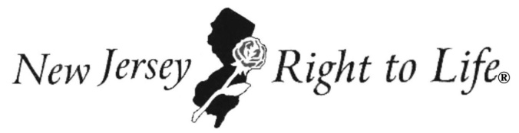

242 Old New Brunswick Road | Suite 340 | Piscataway, New Jersey 08854

New Jersey Right to Life

Invites you to Join us as we Rally for Life

Friday, January 22nd, 2016
43rd Anniversary of the Roe v. Wade
U.S. Supreme Court Decision

State House Steps, NJ Capitol
125 West State Street, Trenton, NJ
11:00 A.M. to approximately 1:00 P.M.

Pro-Life Leaders, Elected Officials and Clergy Expected to Address Rally.
Check our website, www.NJRTL.org, for information regarding weather and last-minute updates.

PLEASE DO NOT BRING SIGNS
SIGNS WILL BE PROVIDED
No signs on sticks are allowed due to State House Regulations

Buses & carpools leaving from various NJ locations.
For more information call: (732) 562-0562

Please e-mail NJRTL if you plan to attend at feedback@njrtl.org

Directions to the Statehouse: DRIVING DIRECTIONS
FROM THE EAST: Take 195 west to Route 29 north (toward Lambertville). Exit right at Memorial Drive. Follow signs for the Capitol Complex and proceed through the light at the end of the ramp. After the light, make a sharp first right and proceed making a semi-circle around the parking area. Pass through the light into the Capitol Complex.
FROM THE SOUTH: Take Route 206 north or 295 north, and follow directions to 195 west to Route 29 north (toward Lambertville). Follow directions above for traveling from the east.
FROM THE WEST: Enter Trenton via Delaware River toll bridge (Route 1 north). Exit at Route 29. Take Route 29 north (toward Lambertville). Exit right at Memorial Drive. Follow signs for the Capitol Complex and proceed through the light at the end of the ramp. After the light, make a sharp first right and proceed making a semi-circle around the parking area. Pass through the light into the Capitol Complex.
FROM THE NORTH: Take Route 1 south to the last New Jersey exit ("Capitol Complex"). Turn right onto Warren Street and go to the light where you will make a left onto Market Street. Pass through the next light at William Trent Place and bear right following signs for the Capitol Complex.

PARKING: Metered, on-street parking is available along West State Street. Pay lots are located at the corner of South Warren and Lafayette Streets, and at North Warren and Hanover Streets. Handicap parking is available in the parking garage and on West State Street in front of the State House and Annex and across the street from the State House. Paid parking is also available at Trenton Marriot, One West Lafayette Street, Trenton.

FROM THE TRAIN STATION
Walking: South Clinton Avenue runs along the left side of the train station. Proceed up the avenue (to your right when facing the road) one block and make a left onto East State Street. (You'll soon pass the Department of Environmental Protection on your left.) At one point, the street becomes a pedestrian mall. After the mall, the street becomes West State Street. The State House is two blocks up on the left. The walk takes 10-15 minutes.

Cabs: Cabs are available at the rear of the train station.

Buses: Buses stop in front of the train station at the corner of South Clinton Avenue. Most service West State Street and the State House.

